**LDAP Server & Client Configuration**

First check server & clients hostname & IP address-









Server Configuration: -

Domain: cricbuzz.com

1. At server, hostname & IP in /etc/hosts file as we don’t have DNS configured-

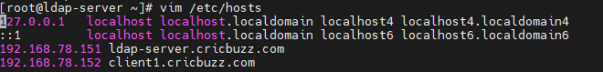

2. Install required packages to setup LDAP-



3. Set password for LDAP & store it in encrypted form-



4. Now we will generate a certificate for 365 days-

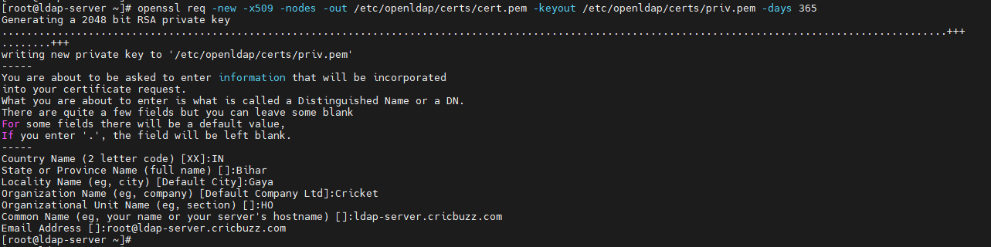

5. Go to certs directory & change files ownership to ldap-

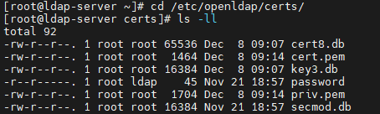

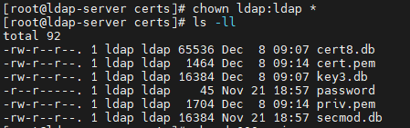

6. Change permission of file priv.pem to give read, write access to file owner only-

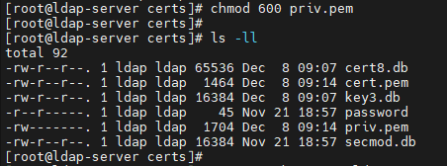

7. Now we will prepare LDAP database & for that copy the DB_CONFIG.example as shown-



8. Now to generate database, we will use command as shown below-



It is giving error, because we need to sync parameters in this file. We will modify it later.

9. We will change file ownership of all the files inside ldap directory to ldap-



10. Start & enable slapd service-



11. Verify whether it is listening on ldap port or not-

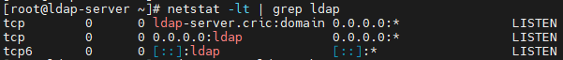

12. Now we go to schema directory for adding schema for ldap & will put configuration from cosine.ldif & nis.ldif file into ldap directory-



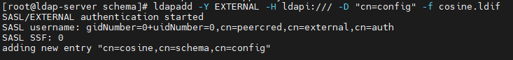

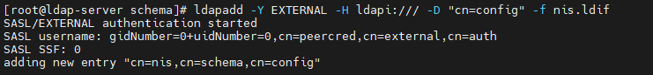

13. We will create one ldif file where we will specify all the parameters-

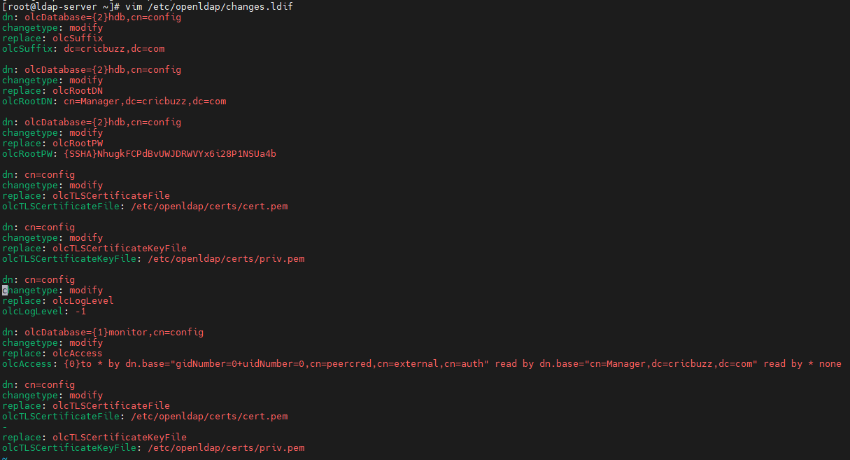

Here we will add that encrypted password for ldap in olcRootPw, generated earlier.

14. Now we will have to add all these entries in ldap using command as shown-

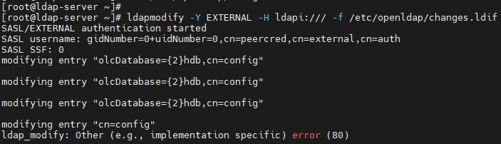

Ignore the last error.

15. Now create base.ldif file inside same directory where we will define few more parameters-

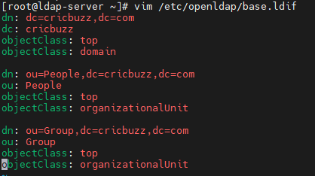

16. To build directory structure, we will add this newly created base.ldif file in ldap-

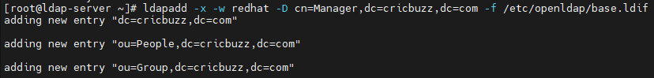

17. We will create home directory for ldap users, create ldap users & set their password-

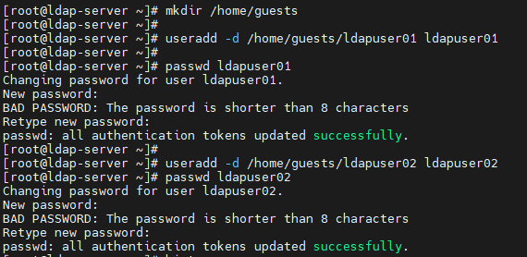

18. Now we will migrate these user accounts. For this we will have to make their entry in ldap directory for authentication to be completed-



19. Next, we will add our domain in shown file-

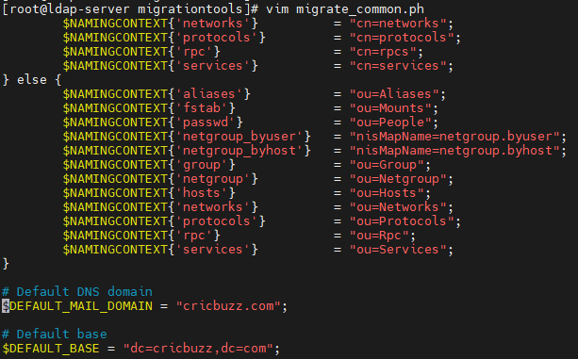

20. Verify the ldap users created locally-

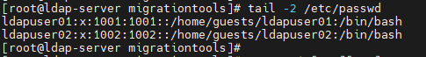

21. Now we will add users whose id equal to or greater than 1000 in same directory inside passwd file & verify the same-

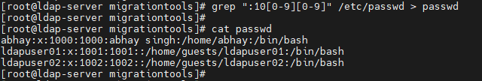

22. We will create users.ldif using one of script file inside migrationtools directory & will verify the same-

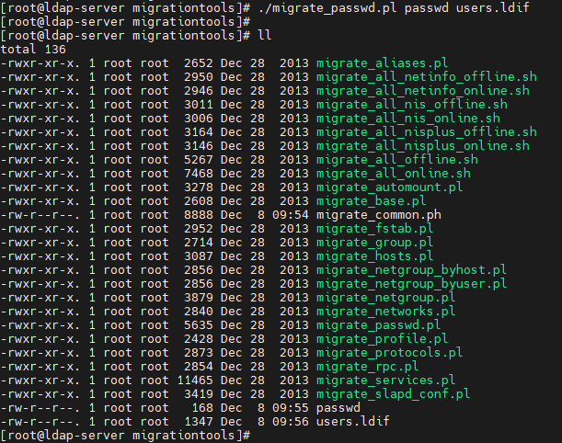



23. Using this file, we will add the users entry in ldap-

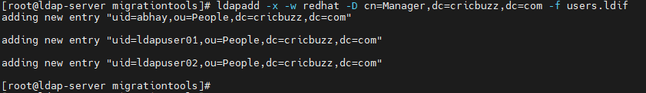

24. We will do the same thing for groups-

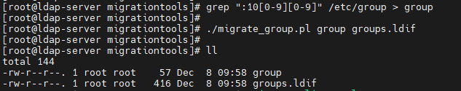



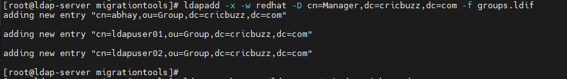

25. Now we will check whether we are able to see ldap user’s entry or not-



We will see success message at last.

26. We will allow ldap service from firewall (It works on tcp port 389)-

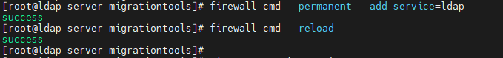

27. Define which file we will use for for ldap logs-

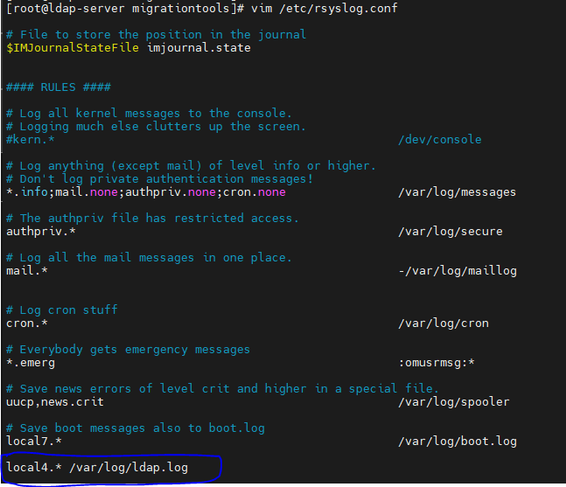

28. Restart syslog service-



29. Next, we will setup nfs in order to mount ldap user’s home directory on client. Install packages for it-



30. Now we will export home directory-



31. We will start & enable nfs, rpcbind services-



32. To check whether nfs configuration is done properly or not-



33. Next, we will add nfs, rpcbind & mountd services in firewall-

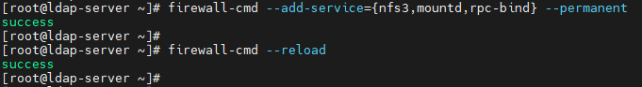

34. We will restart slapd service & get ldap user detail-



LDAP server configuration are done now. Next, we will configure LDAP client.

Client Configuration: -

1. At server, hostname & IP in /etc/hosts file as we don’t have DNS configured-

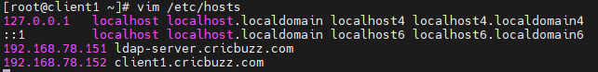

2. We will install few packages as shown-



3. Configure LDAP client using authconfig-tui-

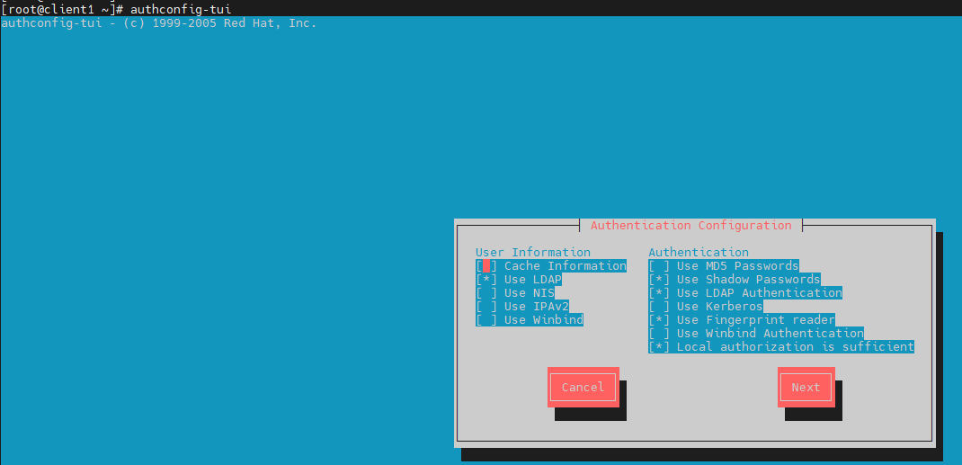

Make sure to select (i) Use LDAP (ii) Use LDAP Authentication.

4. Next, uncheck “Use TLS” option & specify LDAP server IP or hostname-

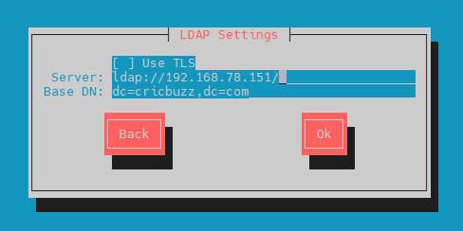

5. Get LDAP user detail-

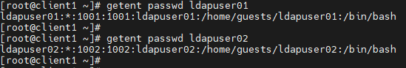

This user is not available this on client. It is available on server.

6. Now we will auto mount these LDAP user’s home directory using autofs. We will create one file for this-



Here, /home/guests is exported path from server & auto.home we will create in next step.

7. Create auto.home file & define which directories are there in /home/guests, permissions on them & from where they are exported-

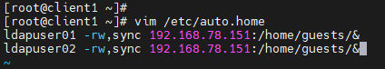

8. We will restart autofs service. These mounts will not reflect if we check using df -h -

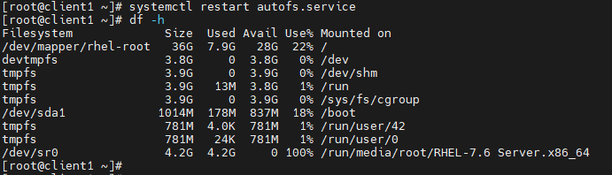

9. Next, we will try to login using ldap users-

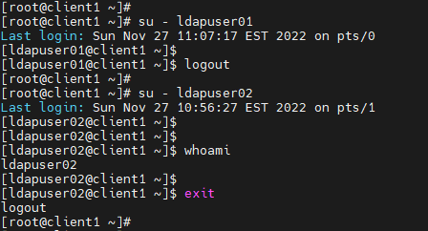

Note: As soon as we login with LDAP user, their home directory gets created on server.

This is all about LDAP server & client configuration.